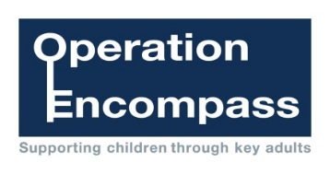

Operation Encompass is a joint operation between Norfolk Children’s Services, Norfolk Police and School. It has been established to provide schools with notification of domestic incidents that have occurred the previous day before 9am or as soon as possible thereafter the following morning. This enables schools to provide timely support to the children and their families. To enable schools to start receiving notifications they must have;
- Read and agreed to the Information Sharing Agreement
- Provide at least 2 nominated members of staff to be Key Adults, they must be Designated Safeguarding Trained and have attended the Operation Encompass Briefing. Informing the named person in the protocol when a Key Adult leaves the school.
- Informed all parents of the school about their intentions to be part of Operation Encompass.

Please complete the form below and return via email to operationencompass@norfolk.gov.uk
Name
Job title
School
Contact Number | (Please include direct dials/mobile numbers if applicable)
Email address | (Please provide work email address for Holiday Notifications)

I confirm that I have read and agreed to the information Sharing Agreement.
I confirm that the school has sent the letter provided to all parents / carers informing them of the schools intentions to participate in Operation Encompass.
I confirm that I understand the sensitive nature of the information I may receive regarding children young people and their families as part of operation Encompass and agree that the school is responsible for the approprriate sharing of that information therafter.

Name:

Job Title:

Signature:

Date:

