NORFOLK SCHOOLS FORUM

AGENDA

Meeting on Wednesday 29 September 2021 09:00 – 11:30
This will be a remote Teams Meeting

It is lovely to say hello, welcome people and see and hear each other at the start of the meeting. However, to support connectivity for all and to minimise interference, please can we ask that once we make a start upon official business can cameras and mics be turned off unless you are speaking. Please also use the hands-up function if you wish to contribute to an item. Thank you

Individual members, named below, are asked to provide verbal reports for these items.
Time | No. | Item | Report | Pages
09:00 – 09:05 | 1 | Welcome and Introductions  Apologies
09:05 – 09:30 | 2 | Minutes of Last Meeting and Matters Arising  - Draft letter to DfE to be circulated to Eastern Region School Forums (Martin White/Dawn Filtness)  - Review demographic changes in Norfolk (discussed in pre-and post-opening costs item at May meeting) - Sebastian Gasse  - Election for 16 – 19 representative on Norfolk Schools Forum |  | 2 - 7
09:30 – 10:00  10:00 – 10:30  10:30 – 11:00 | 3 | Dedicated Schools Grant  - SEND Strategic Improvement  Including Capital update (Michael Bateman)  - Report on Special School Funding Review (Martin Brock)  - Indicative DSG for 2022/23 and Schools Block Fair Funding Consultation options (including Admissions Appeals) (Martin Brock) | Information  Discussion/  Comment  Information/  Comment | 8 – 16  17 - 28  29 - 36
11:00 – 11:15 | 4 | Review Future Meeting Plan |  | 37 - 38
 | 5 | Date of Next Meeting  Wednesday 17 November 2021 at South Green Park, Mattishall  09:00 – 11.30 hours

Norfolk Schools Forum

Minutes of Meeting held on Friday 9 July 2021
09:00 – 11:30 hours
Teams Meeting

Present: Representing
Andrew Aalders-Dunthorne Academies
Adrian Ball, Diocese of Ely Multi Academy Academies
Trust
Keith Bates, Eaton Hall Specialist Academy Special School Academy
Chris Caddamy, (Vice Chair) City College 16 – 19 Representative
Lacey Douglass Early Years Representative
Mike Grimble, Avenue Junior School Primary Maintained Governors
Bob Groome Association of Teachers & Lecturers
Glyn Hambling, Unity Education Trust Alternative Provision
Howard Nelson, Diocese of Norwich Diocesan Board of Education
Carol Jacques Maintained Nursery School
Clare Jones, Boudica Schools Trust Academies
Peter Pazitka, SJB CMAT Academies
Joanne Philpott, City of Norwich School Academies
Sarah Porter, The Heart Education Trust Academies
David Shaw, Creative Education Trust Academies
Sarah Shirras, St Williams Primary Primary Maintained Schools
Joanna Tuttle, Aylsham High School Secondary Maintained Schools
Martin White, (Chair) Nebula Federation Primary Maintained Governors
Rebecca Wicks, The Clare School Maintained Special Schools

Michael Bateman Assistant Director, SEND Strategic Improvement & Early Effectiveness
Martin Brock Accountant, Schools, SEN and Early Years
Marilyn Edgeley Admin Officer
Dawn Filtness Finance Business Partner
Alison Randall Head of Finance, Leadership & Governance Services
Nicki Rider Interim Head of High Needs SEND
Chris Snudden Director of Learning & Inclusion
Apologies:
John Crowley Assistant Director Learning and
Achievement
Sally Cutting Senior Accountant
Seb Gasse Assistant Director Education Strategy & Infrastructure
Sara Tough Executive Director Childrens Services
Vicky Warnes JCC (primary phase)

- Apologies
Apologies were received from John Crowley, Sally Cutting and Seb Gasse, Vicky Warnes had not been able to access the meeting via the join link and subsequently sent her apologies.

The Chair welcomed the new Maintained Special School representative Rebecca Wicks and the new Academy representative Adrian Ball.

- Minutes of the Last Meeting and Matters Arising
It was agreed the minutes were a true record of the meeting.
- Joint letter to the government with other School Forums in the Eastern Region on insufficient funding for the High Needs Block.

A letter to be sent to School Forums in the Eastern Region has been drafted and included in the meeting papers. Members agreed this was an excellent, well put together draft and that the letter should now be emailed to the other Forums for their views on the content..
Action: Draft letter to be sent to Eastern region Forums.

Letter to the Secretary of State jointly from the current Chair and previous Chair of Forum and the reply from John Edwards, Education and Funding Skills Agency is included in the meeting papers for information.

- Re-circulate Management Information Sheet regarding spend on disabled staff criteria
It was confirmed a management information sheet will go out to schools today with information from Carole Human on how to access all dedelegated pots of funding and what they can be used for.

- Review of demographic changes in Norfolk
Due to illness It was agreed this item will be moved to a future meeting when the relevant member of staff will be available to provide an update.

Action: add to agenda of next meeting.

- Dedicated Schools Grant (DSG)
3a. Discuss proposals to include in Fair Funding Consultation (verbal update)
Officers confirmed that no information has yet been received from the Department of Education (DfE). Information on next years funding arrangements is usually released sometime in July and once that happens officers will plan what should be included in the consultation with schools.
Officers recently met with the DfE as part of the Eastern Regional Group meeting and there is a possibility that some indicative information will come through next week. It will be a local formula for 2022/23.We may receive some information on sparsity rates and also on high needs funding. There will be a consultation on a hard formula beyond that.
We will want to progress with the consultation document and options on transfer from the Schools Block to the High Needs Block (0.5% plus an option for an additional amount).
Comments:
- We could use opportunities such as Headteacher meetings to engage with schools on the importance of responding to the consultation.
Action: Sarah Shirras will pass on the dates of these meetings to the chair of Schools Forum.
- Members requested that a breakdown on type of establishments responding as happened last year is part of the process. Also remind people that giving their opinion is important.

3b. Update on Review of Special Schools’ Funding (verbal update)
Keith Bates explained that there is not much detail to report at present. The reason for the review is that Special School Funding levels have not changed for many years. Current funding of £10,000 per place is nationally set – we are focussing on the 5 top-up levels which have not changed since 2013. It is a complex task to obtain benchmarking data on funding and expenses. The group consists of LA Officers, Headteachers and School Business Managers. In due course reports will be brought to School Forum.
Officers added that this was indeed a complex piece of work. The group will also be looking at bandings and how to model for the future, agreeing staffing and leadership ratios within top-up bandings and looking at what processes other LA’s have in place.

Comments:
Glyn Hambling said benchmarking was essential and offered to help getting this information.
Members highlighted that Suffolk County Council are holding a review. Officers said this was a review on delivery of operational service and not on funding. Officers confirmed they have benchmarking information from Suffolk.

- How School Forum Meets in Future
It is acknowledged that there have been some challenges with holding virtual meetings, a necessity during the pandemic. At the last meeting it was suggested that a discussion should be had at how Forum meets in the future.
There are still some Norfolk County Council (NCC) protocols on how we meet and we should model on social distancing.

The September meeting will go ahead as a virtual MS-Teams meeting so this vote is about the November meeting onwards. Furthermore we will be governed by any changing restrictions.

Three core options have been identified; an alternative combination could be considered. Pros and cons of each option are set out in the paper to help with the discussion:
- All meetings on-line
- All meetings in person
- Half on-line and half in person

A vote took place on the 3 options in the paper with the following result:

Half and half 15 (83%)
Face to face 2 (11%)
All on-line 1 (5%)

- Admissions Appeals Charges
At the January 2020 Schools Forum meeting it was agreed that an Admissions Appeals Task and Finish group should be set up to review current arrangements. The group has met to review arrangements over the past year.

This paper is an update on work and provides information to enable members to come to a decision about future funding/charging arrangements and requires Forum to vote on the available options.

The group looked at cost of venues, transparency and costs, communication of the appeals process, charging of academies and free schools and the potential for DSG funding on admissions appeals.

The process has changed since the pandemic and appeals can take place by telephone, video conference or through a paper-based appeal, where all parties can make representation in writing. This has reduced the charge to £150 per appeal.
From October 2021 onwards, DfE guidance states that admission authorities should prepare appeals to be conducted in the normal way.

Accuracy
it should be noted in Option 2 in the paper that Foundation school read Community school
Also any arrangements should be for 2022/23 and not for 2021/22.

Comments:
Excellent report
- Bearing in mind there is a cost to that appeal, will the cost effect whether anyone would go to an appeal or not if they are not picking up that cost directly?
- Answer - Some people’s view may alter if the cost is changed. We have been working through how to communicate to parents the appeals process and the chances of success.
- I think cost would not have an impact more likely schools are considering the complexity to taking an extra student.
- Think we should continue to hold appeals virtually if we are able to.
- No guarantee that any money freed up by option 3 would go to schools.
Officers confirmed this money would not go directly to schools but would be used for learning and inclusion services. We are not going through this process for a budget saving. It is difficult to stipulate how any savings would be used until we know we have those savings.
The member who raised this issue that led to the working group being formed agreed this was not raised as a cost saving but as an equitable process issue.
She reported that a result of the work done by the group has led to a greater awareness among parents of the appeals process and a reduction in the amount of families challenging.
- I think before Forum can make an informed decision we should have an idea about the money would be reused.
- Often the schools that are oversubscribed are the better off schools so paying for this service is often not an issue. Probably fairer that the schools that use the service pay for it. Therefore I think option 2 is a good option.
- Officers confirmed that they would discuss any changes in the estimate of the costs of appeals with Schools Forum. At the end of the year the different blocks off set each other within the DSG budget.
- Greater consultation with schools before a decision is made.

The Chair clarified the position that Forum requires information on how Norfolk County Council would use any savings that occurred from a change in the charging process. It was agreed however to hold an indicative vote to see what further work officers need to do.

Option 1 – Continue with current arrangements. DSG is not used for admissions appeals. NCC budget covers the appeals charges for maintained schools. Academies and Free Schools are charged for their appeals.
No 12 (70%)
Yes 3 (17%)
Abstain 2 (11%)

Based on the response (no to continuation of current arrangements), which of the following options within the paper should be implemented?

- Option 2 – Charge appeals costs to all schools that are their own admissions authority. This includes Academies, Free Schools, Voluntary Aided, and Foundation schools. NCC budget would cover the appeals charges for Voluntary Controlled and Community schools.

- Option 3 - Funding for appeals can be delegated to all schools and academies (i.e. agreed as already delegated within the funding formula to schools via DSG Schools Block). All schools and academies would then be charged for admissions appeals.

- Option 4 - Funding for appeals can be held centrally for all schools and academies. This may require a transfer from Schools Block to the Central Schools Services Block (effectively reducing funding to all schools by an estimated £1.50 per-pupil). No schools or academies would then need to be charged for admissions appeals as the central pot would pay for them.

Votes cast by Forum members:

Option 2 9 (56%)
Option 3 6 (37%)
Option 4 1 ( 6%)

Going forward
Include option 2 in the autumn consultation and do not explore other options at this point.

- Cyber Security – Potential risks to schools (Alison Randall)
This report is to update the School’s Forum on the potential risk to schools and academies of the Cyber Security threat and to inform them of support available.

Officers said that NCC is looking at themed audits to carry out certification work and an audit will take place with 12 schools in the autumn and findings will be circulated to all schools.

Comments:
- Audits – can they be more desk based?
- Post 16 colleges have implemented password changes.
- What can School Forum do?.... Promote awareness.
- Promote the Norfolk approach with flyers.
There are links at the bottom of the report on how to access NCC resources
Action: Alison Randall will talk to IT about classroom flyers.

Forum noted the information provided.
- Review Future Meeting Plan
- Next meeting – Consultation to include Admissions Appeals
- Early Years – maintained nursery supplement, a hint this may be looked at
- High Needs – We may have information on new arrangements.
- Report on Special Schools’ Funding Review.
- Look at transfer to High Needs Block once we have DSG figures and discuss disapplication request.

- Elections
Chris Caddamy’s term of office will be up in august. The Deputy Principals of Post 16 providers will decide if they are happy for Chris to continue or if they wish to nominate someone else.

- Date of next meeting
29 September 2021 09:00 – 11:30

Item No. 3a
Report title: |  | SEND Strategic Improvement
Date of meeting: |  | September 2021
Report by: |  | Michael Bateman, Assistant Director SEND Strategic Improvement and Early Effectiveness
Context
NCC Children’s Services is currently leading three programmes of improvement work for special educational needs and disability (SEND) which, taken together, combine to set our overall SEND Strategic Improvement planning, these are:

- Area SEND Strategy (2019-2022)
- SEND & Alternative Provision Transformation Programme (2019-2024)
- Ofsted/CQC Written Statement of Action (2020-2022)

Previous reports to Schools forum regarding the High Needs Block recovery plan relate directly to the SEND & Alternative Provision transformation programme, with that programme containing the project work to develop the three new special schools and the increased range of specialist resource bases.

The other improvement programmes, Area SEND Strategy and Written Statement of Action, have a focus on partnership working across NCC and the Clinical Commissioning Group (CCG) alongside education and health providers and parent/carer groups. In particular these improvement programmes contain project work to improve timescales and quality of Education, Health & Care Plans (EHCP), transition to adult life, communication and co-production with stakeholders and partners and the ongoing focus on ensuring local inclusive mainstream provision across early year settings, schools and colleges.

The report today sets out the key developments across this programme of work so that members of Schools’ Forum are aware of how these interact with the High Needs Block recovery plan.

1. | Area SEND Strategy  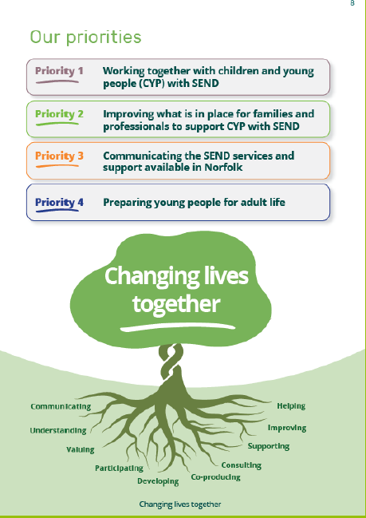  Information in this image is available at: https://www.norfolk.gov.uk/what-we-do-and-how-we-work/policy-performance-and-partnerships/policies-and-strategies/send-policies/send-strategy  - Original strategy 2019-2022  - refreshed and published spring/summer 2021  - fully co-produced with partners in compliance with Ofsted/CQC Written Statement of Action commitments  - Four over-arching priorities, underpinning all Norfolk SEND strategic improvement work  - Working together with children and young people with SEND  - Improving what is in place for families and professionals to support children and young people with SEND  - Communicating the SEND services and support available in Norfolk  - Preparing young people for adult life  - Area SEND Strategy to be recognised as the ‘permanent’ strategic plan, current and future ‘task and finish’ work located within it  - Ofsted/CQC written statement of action  - SEND & AP transformation programme  - SEND & Alternative Provision sufficiency planning  - Budget recovery and effectiveness  - National SEND Review  Information shown in the images below available at: https://www.norfolk.gov.uk/what-we-do-and-how-we-work/policy-performance-and-partnerships/policies-and-strategies/send-policies/send-strategy
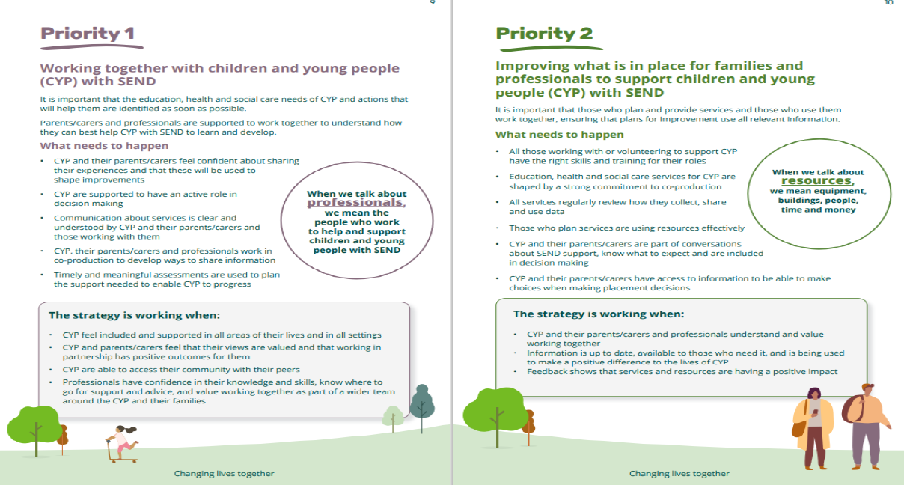
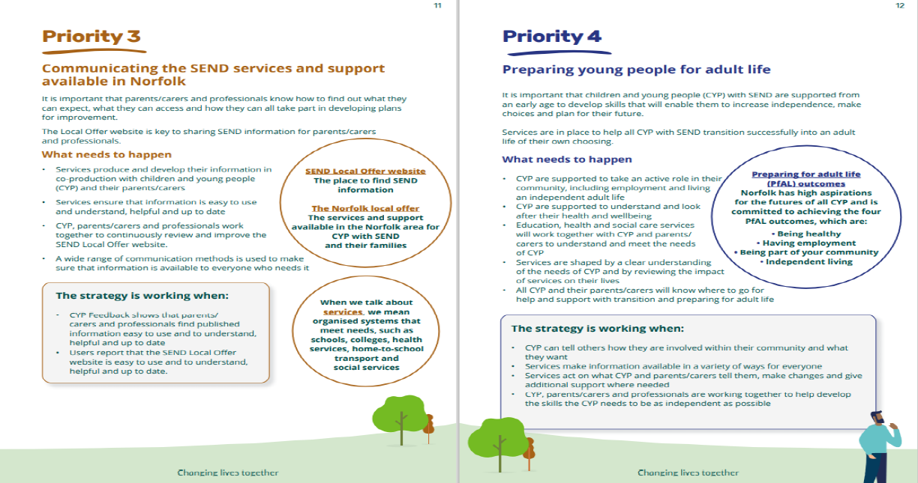

Link here to the full area SEND strategy via the SEND Local Offer website:
Area SEND strategy - Norfolk County Council
2. | SEND and AP Transformation Programme  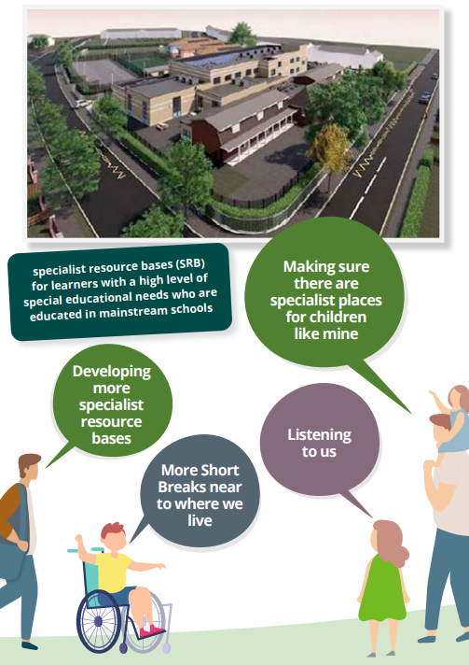  Information in this image is available at: https://www.norfolk.gov.uk/what-we-do-and-how-we-work/policy-performance-and-partnerships/policies-and-strategies/send-policies/send-strategy  - Capital Programme broadly unaffected by COVID, opening dates for new special schools in line with previous reporting  - Great Yarmouth SEMH (Bure Park) opening September 2021  - Fakenham ASD (Duke of Lancaster) opening Spring 2022  - Easton Complex Needs opening 2023  - EHCP performance improvement moved into Ofsted/CQC WSoA plan  - Alternative Provision  - New sufficiency strategy  - Improvements to local authority tuition for pupils without a school place  - Ongoing review of models within other local authorities to continue emphasis on reducing exclusions  - Finance Benefits Realisation  - Dedicated School Grant recovery plan agreed with DfE and continued monitoring via Schools’ Forum, with ongoing pressure and cumulative overspend currently forecast £66m+ by 2024/25  - Home To School Transport pressure/savings agreed £1.7million  Bure Park (Great Yarmouth) – Open from September 2021  - For Social Emotional & Mental Health difficulties (SEMH)  - Boys age 5 to 16  - Total places 86  Image of Bure Park Specialist Academy:  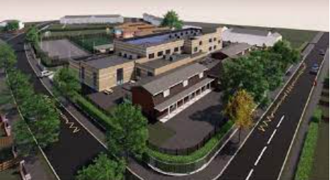  Duke of Lancaster (Fakenham) – Opening January 2022  - For Autistic Spectrum Disorder (ASD)  - Boys and girls age 5 to 16  - Total places 96  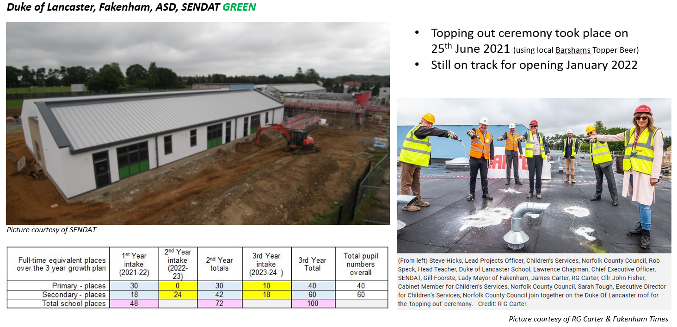  Easton (Name to Be Determined) – Opening Spring 2023  - For Complex Needs  - Boys and girls age 3-19  - Total places 170  Map showing Easton School plans:  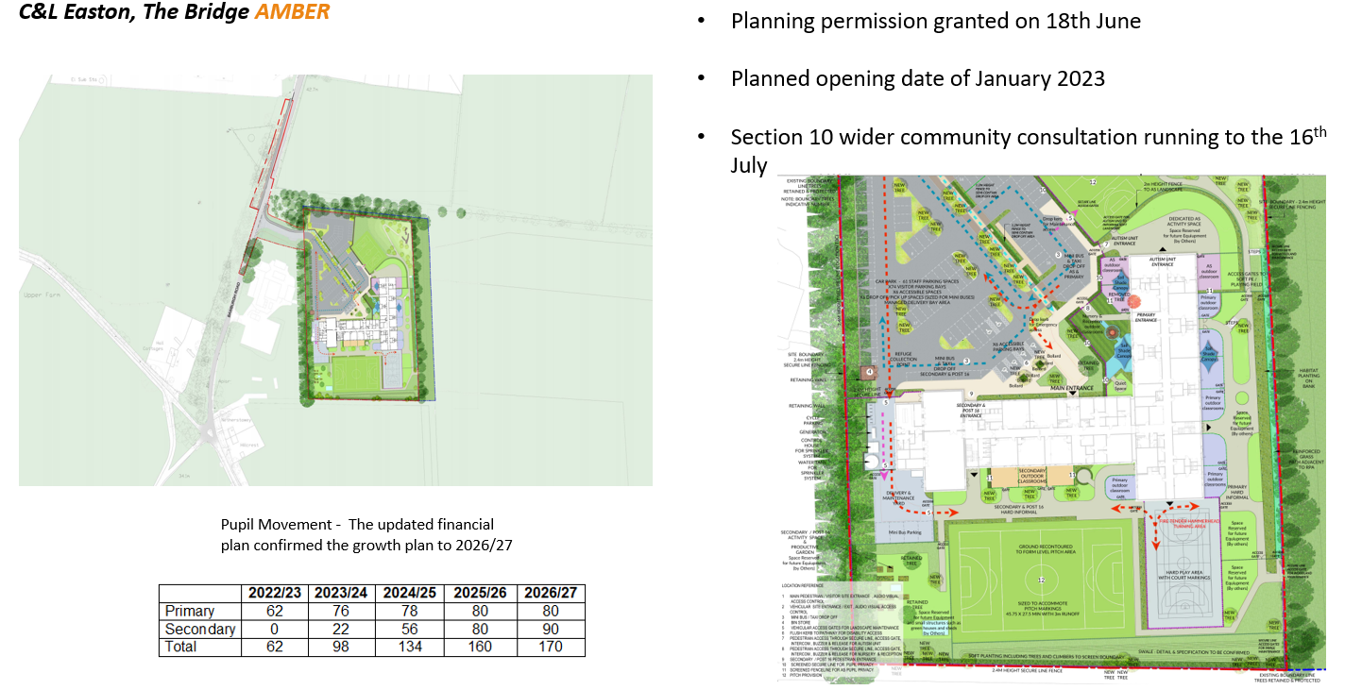  Link here to the transformation programme via the SEND Local Offer website:  SEND transformation programme - Norfolk County Council  Link here to the SEND Bulletin for latest news on other developments, including Specialist Resource Bases, via the SEND Local Offer website:  SEND newsletters - Norfolk County Council
3. | Written Statement of Action
 | 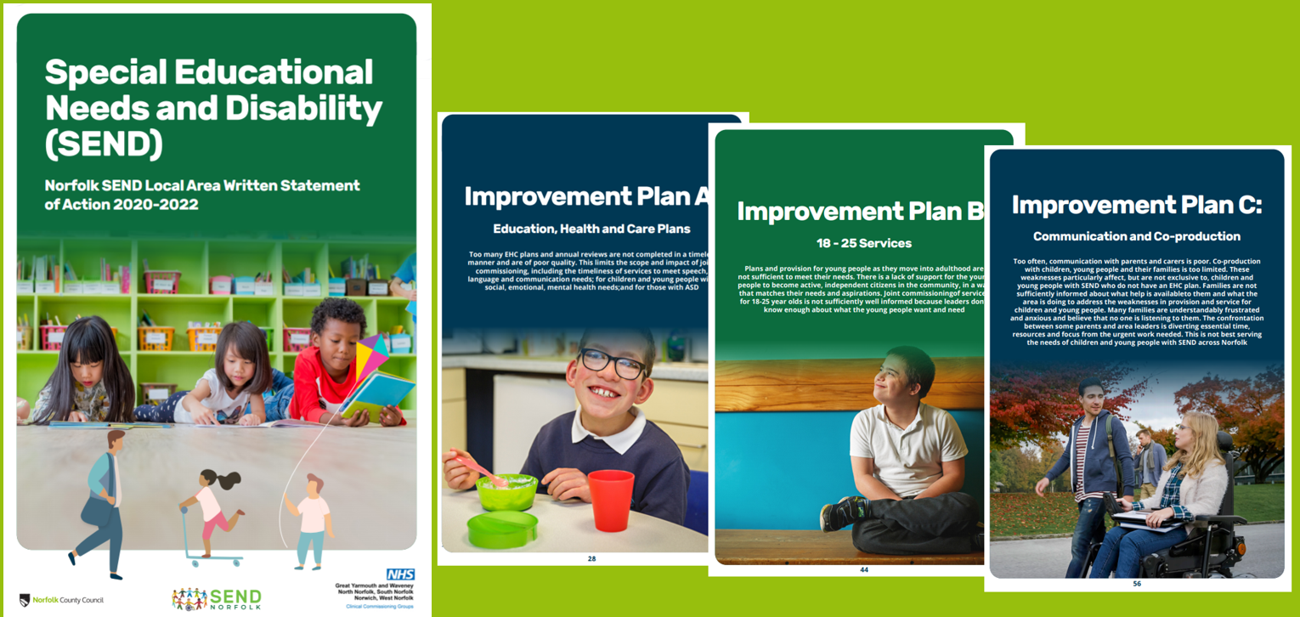
  - Agreed action plan with Ofsted following Area SEND inspection in March 2020
    - March 2020, original inspection
    - June 2020, notification of 3 serious weaknesses
    - September 2020, Norfolk’s Written Statement of Action agreed
    - Spring/Summer 2022, Ofsted/CQC Re-inspection
  - Three serious weaknesses
    - Education Health & Care Plans
    - 18-25 Services
    - Communication & Co-production
  - Executive Board governance to monitor progresses of 109 individual actions within action plan
    - Currently 87% of actions ‘green or blue’
    - EHCP performance on trajectory towards target; capacity issues flagged
    - Joint Commissioning Framework across Children’s, Adult Services and CCG
    - Co-production approach being linked to other Children’s, Adult and corporate approach to Participation

 | At the time of our Ofsted/CQC SEND inspection, which took place in March 2020, a total of 8% of EHCP’s were completed within the required 20 week timescale. The SEN2 data set, submitted to DfE in January this year and published nationally in May this year, confirms Norfolk’s published performance for the 2020 calendar year as 21% As can be seen from the table below this has now increased to 52% (cumulative calendar year to date, with 60% in July) following the investment in more staffing capacity and the implementation of a new operating model for the High Needs SEND Service.
Therefore, our trajectory is currently on target for EHCP performance within 20 weeks:
- 2019 Norfolk Performance = 8%
- 2020 Norfolk Performance = 21%
- 2020 National Average = 58%
- 2021 Norfolk Performance (to date) = 52%
- 2021 Norfolk Target = 60%
- 2022 Norfolk Target = 90%

However, we are experiencing increasing referral rates for EHCP and also capacity issues within Educational Psychology teams; there is a risk that these elements impact on performance trajectory if we are not able to address these dual pressures.
Work continues to understand the ongoing rise in EHCP referrals from schools and parents, when there are other options available to access advice, guidance and funding at ‘SEN Support’ in addition to our review of Educational Psychology capacity.
There are a total of 109 actions across the Written Statement of Action; one year into this improvement programme (ahead of scheduled reinspection spring/summer 2022) we are currently on track with 87% of actions either completed or on target within timescale:

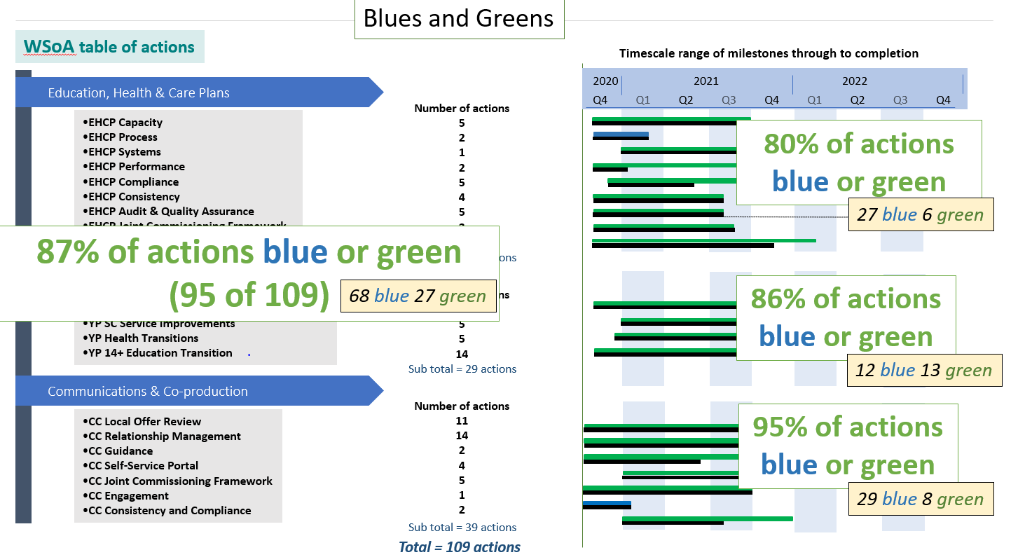
Link here to the Written Statement of Action full programme as agreed with Ofsted/CQC via the SEND Local Offer website: SEND statement of action - Norfolk County Council
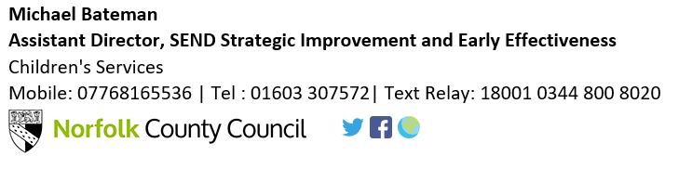

Schools Forum
Item no: 3b
Report title: | Special Schools’ Funding Review
Date of meeting: | 29 September 2021

Executive summary:

The funding of Norfolk’s special schools has not been reviewed or increased since 2013. NASSH and NASSA raised concerns as to the appropriateness of the current funding model in relation to special school costs and need requirements.

Norfolk LA agreed to carry out a review of special schools’ funding and during 2021/22 has looked at many different elements including benchmarking against other authorities, the make-up of leadership structures, staffing ratios, site costs, the impact of school size and other additional costs including specialist equipment.

A task group was formed to analyse findings and to propose a new funding methodology going forwards.

This report sets out a summary of the research carried out, the findings and an overview of the proposed new funding methodology going forwards, and possible questions for autumn consultation with all special schools.

This paper is provided for discussion and feedback ahead of the local authority preparing a consultation document for the funding of Norfolk’s special schools in the financial year 2022/23.

Confirmation of guidance is awaited, but it is anticipated at this stage that the consultation will be with the special schools, but open to anyone else who has a view.

The final decision regarding funding methodology, including any subsequent change to top-up values, is the responsibility of the Local Authority in accordance with DfE guidelines and NCC’s constitution. If appropriate, an Equality Impact Assessment will be completed prior to any decision making, including in relation to any cap on gains and / or protection for losses arrangements put in place.

The Local Authority are aiming for consultation to take place between the 4th- 22nd October with feedback going to Schools Forum in November.

- Introduction/Background

In February 2020 Norfolk Association of Special School Administrators (NASSA) sent a letter to the Local Authority expressing their concerns that special school funding had not been reviewed for a number of years.

The special schools are all forecasting declining balances in 2022/23, and on average across the nine LA maintained schools the decrease is 3.17% of their income (i.e., a shortfall of this amount for the financial year). In 2023/24 this average decline is forecast to be 5.71%.

Historically, Norfolk’s special schools have forecasted declining balances, however between 2016/17 and 2020/21 there has actually been an average increase in balance of £121,818 across the nine maintained schools. We must note that in part, this could be due to the pandemic and a potential reduction in spending last year due to partial closures, with £95,305 of this increase occurring during 2020/21 (and, therefore, £26,513 between 2016/17 and 2019/20).

- Overview of existing funding methodology

Each child attracts £10,000 place funding and then a top-up is applied to each child dependant on level of need.

Currently, Norfolk allocates top-ups based on 5 bands, increasing in level of need, as follows:

Band A £2,000
Band B £8,000
Band C £12,609
Band D £17,927
Band E £27,063

On top of the above values, an additional £346.46 is added to each banding (including ‘PB’ Place Based) for the delegation of previously centrally held budgets such as staffing supply cover e.g., maternity cover – which special schools are now able to buy-back into if they wish to.

A percentage uplift to top-up values is provided for smaller schools, based on them having had their funding level protected when the funding reforms were introduced in 2013. Some of these schools have since grown in size, but still attract the same level of uplift on their top-up values, which is an anomaly of the current system.

A place-based child attracts place funding of £10,000.

The existing model was worked using salaries as follows, which have not been updated since the introduction of the current formula:

- Teacher salary of £40,000 (assumed to have included on-costs)
- Support staff salary of £17,000 (assumed to have included on-costs)
At a place-based level of funding the method assumes a class of 10 pupil with one Teacher and two Teaching Assistants. As the level of pupil need increases, so does the required teaching staff input and this is reflected in the different band values.
There is an allowance of £1,952 made for the fixed costs of the school, such as leadership, utilities, and premises at all levels of banding although this is now thought to be too low to cover the current costs. The existing method also allowed a balancing figure of £648 which was described as an ‘additional admin cost’. Therefore, a total of £2,600 per-pupil was allowed to cover everything other than teaching and support staff salaries. Further additional amounts of £1,000 and £1,500 were added for bands D and E respectively to cover ‘additional equipment’.

- Benchmarking

We used https://schools-financial-benchmarking.service.gov.uk to compare Norfolk against our ten closest statistical neighbours for revenue balances, income, expenditure and workforce levels. Our statistical neighbours are:

- Suffolk
- Cornwall
- Lincolnshire
- Cumbria
- Somerset
- Devon
- Shropshire
- East Sussex
- Isle of Wight
- Derbyshire
Key points:

- The average revenue carried forward balance as at 19/20 was £125,299 for our special schools which is the lowest of all our statistical neighbours.

- Our average income and average spend per pupil is the second highest of our statistical neighbours, with just Derbyshire ahead. As expected, those that have more income spend more money. The order that the authorities appear in the income and expenditure tables per pupil is similar.

- For workforce levels (full time equivalent of staff per pupil) Norfolk rate third highest – but the difference between the authorities overall is minimal.

Norfolk has the third lowest ratio (lower ratios equate to fewer pupils per teacher) for pupil number to teachers with 6.41 pupils per teacher. Norfolk falls mid-point amongst of statistical neighbours for pupil / teaching assistant ratios with an average of 3 pupils per teaching assistant.
- For leadership levels we are in joint position with Derbyshire as fourth highest in terms of leadership FTE per pupil.

- Broadly speaking there is no difference in the Ofsted gradings for special schools across the local authorities considered.

- Potential new banding model

We presented a potential new draft model to the schools just prior to the summer holidays.

Leadership:

Leadership costs have been calculated on a ‘best fit’ basis across different sizes of school. The leadership costs have been split into a ‘fixed cost’ and a ‘per pupil’ element, with an approach which spreads the fixed element across the different sizes of school via an uplift to the top-up value. All sizes of school have allowance for a Head, Deputy HT and a School Business Manager. We have also allowed for two TLR points at TLR1 Max to for key stage leads / phase leads. One Assistant Head is added in from school size of 150 pupil onwards, and two Assistant Heads for a school of 250 pupils.

We have used the Teachers Pay & Conditions document 2020 to determine the level of leadership pay dependent upon which ‘leadership group’ the schools fall into. This was generally accepted as a reasonable method.

For this ‘best fit’ model for leadership a cost of £1,174 per pupil must be allowed for and in addition a fixed sum of £167,883 (via uplift to top-ups) which must be covered for all sizes of school. For every school other than the largest at 250 pupils, an uplift to the top-ups would be required to meet that fixed cost.
The proposed uplift mechanism replaces the historic system of cash-based protection from 2013 and aims to make it fair across the board by applying the same formula to all schools. The £167,883 fixed sum required is spread over a schools’ pupils based on school size and the average needs profile of the children. This ensures that all schools receive the same basic amount which is then supplemented by the per-pupil amount within the individual band values to meet the costs of a leadership structure appropriate to school size.

Teaching Ratios and average salaries:
In our modelling, for teaching and educational support (teaching assistants) we have used salaries of:

- £55,658 – Point 6 on MPR with max SEN
- Support Staff: £18,261 – Top of scale D (32.5 hrs per week/ 44.1 weeks year)
Both of these figures include on-costs.
The LA’s Senior Advisor for SEND Provision and Funding and schools finance support colleagues (Educator Solutions) agreed these as reasonable average salaries to use for our model. Overall, the schools thought the support staff salary was too low and we did consider this concern. On balance, however, we decided it would be kept as a reasonable mid-point and recognised that pay for a Teaching Assistant could be set anywhere between bands C to E.
Teaching ratios have been the subject of much discussion and debate, and it is difficult to reach an agreement that will suit all schools. We do have some limited information from other local authorities as a comparison, although this is only for three other local authorities as the information has been difficult to obtain. The ratios we have used in modelling are shown further down in this report, and after reflection by the group, are understood to have been accepted overall by the schools participating in the review group.

Other non-teaching costs:
Using information from View My Financial Insights, Oracle transactions and salary information provided in Spring 2021 by the schools we have calculated the ‘other’ non-teaching costs involved with running the schools. We have worked it on a per-pupil basis to allow it to work within the new draft model.
The categories of expenditure included are:
- Premises (staff, maintenance, cleaning etc)
- Occupation (energy catering insurances etc)
- Supplies & Services (educational supplies, ICT, professional services)
- Admin & clerical (staff and supplies)
- Other costs (indirect employee costs, training, special facilities)
- Welfare / medical and ‘other ‘staff
This comes to £5,172 per pupil if we use 20/21 actual costs and allow a separate additional amount for those schools with pools. This seems to be a more appropriate level of funding than the current £2,600 included within the formula that has not been increased since 2013.
Looking at benchmarking data to compare these non-teaching costs with other LA’s who are statistical neighbours, Norfolk appears to be roughly in line with other authorities. Given the time available to review the information, this approach seems to be reasonable, and it was agreed at the review group that it would be very difficult to look further into individual costs without spending a lot more time on it.

Swimming Pools:
Using the information from Oracle financial transactions for 2020/21 the average per-pupil cost for swimming pools works out £321. This also includes costs of instructors which we pulled from the staffing information that most of the schools provided in the Spring.
This £321 is made up of the additional costs as below:
- Water, sewerage & energy £101 per pupil
- Premises costs, staff/ instructors and cleaning services £220 per pupil
After discussion with the schools on 10 September 2021 it was agreed that the calculated costs were about right for schools with pools, and the LA observed that for a school of 100 pupils a pool would be funded at approximately £32,000 in addition to other top ups, based on the 20/21 information.
The two schools which had pools indicated that additional staffing is required to meet health and safety requirements i.e., an additional TA or Instructor is needed as a ‘spotter’ on the side of the pool. It is proposed that when taking the cost of the additional staffing into account, funding of £32,000 per pool is appropriate and this could be allocated to schools via the banding ‘uplift’ system (so that schools with more or less than 100 pupils would receive the same £32k allocation based on initial budget share pupil numbers).
Residential:
It was agreed that residential costs should be considered separately as part of an ongoing review.

- Financial implications

These are the teaching ratios used in the modelling, after much discussion and deliberation at the funding group meetings:

Current Band | Modelled  Band | Pupil/Teacher Ratio | Pupil/TA Ratio
PB | 1 | 12:1 | 12:1
A | 2 | 10:1 | 10:1
B | 3 | 8:1 | 4:1
C | 4 | 6:1 | 3:1
D | 5 | 6:1 | 1.25:1
E | 6 | 4:1 | 1:1

Based on these staffing ratios, plus leadership, and other costs discussed by the group, the £10k place funding would be arrived at as shown in the table below (note that there is an excess of £1,187 that is not affordable within the £10k place funding so this amount would need to be paid via the proposed band values instead):

 | £
Leadership Structure | 672 | Schools below 250 pupils to receive sliding scale uplift
Teaching MPR6 Max SEN | 4,638 | Minimum teaching at 12:1 ratio @£55,658
TA, Top of D Pt16 32.5 hours | 1,522 | Minimum TA at 12:1 ratio @£18,261
Premises Costs | 1,394 | Cleaning, caretaking, site, etc. staff, building and grounds
Occupation Costs | 705 | Water, refuse, sewerage, catering, energy, insurance, rates
Supplies and Services | 1,276 | Educational/admin supplies, bought in professional services
Admin/Clerical/ICT Staff | 981 | Admin/Clerical/ICT
Excess over £10k | (1,187) | Excess over £10k to be paid via band values
 | 10,000

The resulting final band top-up values (based on 1.25 pupils:1 TA at band D) would be as shown in the table below:

Current Banding | PB | A | B | C | D | E
Modelled Top-Up Bandings | 1 | 2 | 3 | 4 | 5 | 6
Leadership Structure | 1,174 | 1,174 | 1,174 | 1,174 | 1,174 | 1,174
Basic Staffing/Other in excess of £10k | 1,187 | 1,187 | 1,187 | 1,187 | 1,187 | 1,187
Additional Teaching (based on ratios) | 0 | 928 | 2,319 | 4,638 | 4,638 | 9,276
Additional TA (based on ratios) | 0 | 304 | 3,044 | 4,565 | 13,087 | 16,739
Welfare/Medical/PSA etc (provided by schools) | 816 | 816 | 816 | 816 | 816 | 816
TPG/TPECG Contribution (towards salary costs) | (660) | (660) | (660) | (660) | (660) | (660)
Delegated amounts (e.g. maternity) | 365 | 365 | 365 | 365 | 365 | 365
Modelled Band Values Before Uplift | 2,882 | 4,114 | 8,245 | 12,085 | 20,607 | 28,898

The changes to current band values are shown in the table below:

Current Banding | PB | A | B | C | D | E
Modelled Top-Up Bandings | 1 | 2 | 3 | 4 | 5 | 6
Modelled Band Values Before Uplift | 2,882 | 4,114 | 8,245 | 12,085 | 20,607 | 28,898
Current Band Values Before Uplift | 364 | 2,364 | 8,364 | 12,973 | 18,291 | 27,427
Change in Band Value (£) | 2,518 | 1,749 | (120) | (888) | 2,316 | 1,470

Leadership element

In order to meet those fixed costs of leadership (£167,883) mentioned previously, we would need to add the following amounts per-pupil for the different sizes of school.

School Size (Pupils) | 50 | 100 | 150 | 200 | 250
Fixed leadership required per pupil | 2686 | 1007 | 448 | 168 | 0

The largest size of school of 250 pupils would not need any uplift as the number of pupils would be sufficient to fund the fixed cost alone. Any school less than 250 pupils would need to have a sliding scale of uplift applied to the band values in order to meet the calculated fixed element of £167,883 for leadership.

Based on the average top-up value of the 6 modelled bandings, £12,805, the percentage uplifts to band values required would be approximately as follows:

School Size (Pupils) | 50 | 100 | 150 | 200 | 250
Uplift adjustments required: | 21% | 8% | 3% | 1% | 0

Ultimately each school has a different average banding, which is based on their individual profile of pupil needs/banding levels. Due to this, the uplift percentage would need to be adjusted for each school to consider the individual banding profile of the school as well as school size.

We ran this through as a model with the review group taking into account the banding profiles of the individual schools and the financial impact was estimated as follows:

School | Current Model | New Bandings | Change | % Change
Chapel Green School | 2,546,922 | 2,522,510 | (24,411) | -1.0%
John Grant School | 3,440,777 | 3,612,345 | 171,569 | 5.0%
Sheringham Woodfields School | 3,380,536 | 3,407,731 | 27,195 | 0.8%
Churchill Park School | 4,089,821 | 4,320,284 | 230,462 | 5.6%
The Clare School | 3,105,109 | 3,168,130 | 63,021 | 2.0%
Harford Manor School | 2,170,342 | 2,245,050 | 74,709 | 3.4%
The Parkside School | 3,255,871 | 3,475,163 | 219,292 | 6.7%
Hall School | 2,188,657 | 2,214,905 | 26,249 | 1.2%
Sidestrand Hall School | 4,141,516 | 4,382,222 | 240,706 | 5.8%
Fred Nicholson School | 4,244,922 | 4,345,325 | 100,403 | 2.4%
Eaton Hall Academy | 2,504,363 | 2,457,487 | (46,875) | -1.9%
The Fen Rivers Academy | 1,273,562 | 1,273,562* | - | 0.0%
The Wherry School | 2,950,195 | 2,950,195* | - | 0.0%
Bure Park Specialist Academy | 670,385 | 670,385* | - | 0.0%
Duke of Lancaster School | 239,670 | 239,670* | - | 0.0%
 | 40,202,647 | 41,284,966 | 1,082,320 | 2.7%
*Subject to agreed top-up during growth

Two schools would lose out under this model, and we would need to consider whether and how those schools could be protected.

In total, this new methodology of funding would indicate a £1.24M increase in funding for Norfolk’s special schools for 2022/23 (including £1.082M for band values as modelled below and a further £0.160M for pool costs not yet included in the modelling). This is approximately 3.1% more than their total current funding (similar to the forecast shortfall of income for 2022/23 across the schools that provided data).

Additional points:

- These figures exclude the schools that currently have their own special top-up arrangement during their growth phase.

- In addition to the individual budget variances modelled above, schools with swimming pools could attract an additional £32,000 per pool.

- Minimum Funding Guarantee (MFG)
We must be mindful of the special schools Minimum Funding Guarantee (MFG) which states that a school’s total budget per-pupil must be no less than it was in the previous year. If we were to change the top-up band values, we need to ensure that the financial impact on the schools has been fully considered.

Modelling suggests that two schools may be affected by losses and, if necessary, consideration could be given transitional protection, to help with the changes. This is something that we would need to build into a consultation with the schools.

If the MFG protection was to be breached (i.e., if we allowed a school’s per-pupil amount to decrease between years based on like-for-like pupils), then a disapplication request would have to be made which would then be considered on a case-by-case basis by the DfE and Secretary of State. The local authority also has to consult with Schools Forum and the schools concerned.

Due to the methodology of changing uplifts as the schools grow, MFG would need to be considered whenever the uplift percentage is reduced for a school. This could be a frequent occurrence as pupil places are added. It is proposed that we should fix the uplift percentage for each school once each year for the purpose of determining whether an MFG disapplication is required for the following year.

- Summary
It is difficult to draw firm conclusions from benchmarking data around financial similarities and differences as there are too many unknown variables involved when data is provided for this purpose. Benchmarking does give an indication that Norfolk Special Schools receive a reasonable level of funding in comparison with most, however the forecasted decline in balances of our Norfolk special schools should not be ignored.
The proposed methodology of modelling ensures increased transparency over the current system in showing which costs are covered by the basic £10,000 and which are not.
The funding group has attempted to complete a fair review and has looked at all aspects of expenditure for our special schools, with a particular focus on staffing costs as these make up the majority of costs within schools budgets. However, there are areas that, given more time, could have benefitted from a more detailed review, e.g., those costs outside of leadership, teaching and teaching assistant staffing. For those costs we have had to use a combination of staffing information provided by schools, and actual spend compared to benchmarking to check reasonableness against other authorities.
Following a meeting of the Special Schools Funding Review Group review on 15 September 2021 agreement was reached upon the main principles of this model for consultation with all of Norfolk’s special schools.
A fixed addition to funding of £32,000 per swimming pool was also accepted as correct, if we take account of the additional staff required to ensure health & safety requirements are met, to be allocated via the uplift mechanism.
However, the following points / questions were raised which will need to be considered further as part of the consultation:
- When will we review the top up model again? There were two strands to this issue – firstly updating regularly for inflation, and secondly reviewing the formula itself?
- A school which is spread over multiple sites ultimately incurs additional costs. The estimate of additional costs for having a split site are around £4,000 - £5,000 to cover:
- separate refuse collection
- separate clinical waste
- boiler/alarm/telephone/broadband fees
- site management support/on-call systems
This does not take into account other low-level costs such as trollies, back-packs and mileage costs.

In addition, it has been suggested that an additional 20% FTE of an Assistant HT is required for schools with a split site.

Should these costs be added to the proposed formula?

- Considering the wider picture around the current deficits within the High Needs Block, should there be a cap on the gains that can potentially occur for some schools? Likewise, should there be a cap on losses (if we were not to apply the default MFG protection)?

- Should we protect those schools that are losing money if we were to adopt the draft formula?
Should an addition be worked into the formula for those schools with a very large site?

- Some of the per pupil amounts for items such as premises and energy were taken from actual 2020/21 expenditure. As this was the year most affected by the pandemic, it was thought that we should use 19/20 as our guide year instead, as this was more indicative of spending levels.

- Suggested Consultation Questions

Leadership
- Are the assumptions for an average number of leadership roles required for each size of school reasonable?
- Are the salaries used in the modelling, from Teachers Pay and Conditions Document reasonable? (Methodology to be explained fully in consultation document).
- Are the principles behind the best-fit method for leadership costs reasonable? i.e providing funding for an element of fixed costs which can be met from uplift if required plus an amount per-pupil which reflects size of structure.
Classroom Staff
- Are the suggested average salary costs fair for teaching and TA staff?
- Are the suggested average teaching ratios correct to meet the needs of pupils?

Other Costs
- Is it agreeable that other costs (excluding leadership, teaching and TAs’) should be revisited and updated if required once we have another full year of costs that have not been affected by the pandemic?
Further Questions
- How often should the formula be reviewed, for methodology and also for inflation?
- Should the cost of hydrotherapy pools be added as ‘fixed sum’ via the uplift mechanism at a cost of £32k per pool?
- Should the additional costs of split sites be recognised within the formula for schools with multiple sites, and should there be a minimum limit to distance to qualify?
- Should there be a cap on gains?
- Should we protect schools against losses (default is to apply MFG so that they cannot lose on a like-for-like per-pupil basis between years), or request to disapply the MFG regulations in these cases?
- Should any protection be transitional, and if so, for how long should this be given?
- Should an additional amount be worked into the formula for schools with a very large site?
- Should the band values for units within special schools be funded at the same level as for the main school?
- Should we continue to use average band values for starters and leavers?
- Does the proposed formula meet the needs of special schools?

This paper is provided for discussion and feedback ahead of the local authority preparing a consultation document for the funding of Norfolk’s special schools in the financial year 2022/23.

Confirmation of guidance is awaited, but it is anticipated at this stage that the consultation will be with the special schools, but open to anyone else who has a view.

The final decision regarding funding methodology, including any subsequent change to top-up values, is the responsibility of the Local Authority in accordance with DfE guidelines and NCC’s constitution. If appropriate, an Equality Impact Assessment will be completed prior to any decision making, including in relation to any cap on gains and / or protection for losses arrangements put in place.

The Local Authority are aiming for consultation to take place between the 4th- 22nd October with feedback going to Schools Forum in November.

Schools Forum
Item No.3c

Report title: | Indicative DSG Allocations for 2022/23 and Fair Funding Consultation options for local formula
Date of meeting: | 29 September 2021

Executive summary
This report sets out indicative levels of DSG funding for 2022/23 and the Local Authority’s proposed options for consultation with schools for the 2022/23 mainstream schools’ local funding formula including:
- Mirroring of updated National Funding Formula factor values;
- Indicative Minimum Funding Guarantee and Cap values;
- Potential levels of transfer from Schools Block to High Needs Block to meet ongoing demand upon high needs placements and support, and as part of the DSG deficit recovery plan.
Schools Forum are asked to:
- Note the increase in overall DSG funding for 2022/23
- Consider and comment on the proposed options that the Local Authority will consult schools on for the 2022/23 schools’ funding formula, including potential transfers of Schools Block funding to High Needs Block and proposed changes to admissions appeals charges.

- Background and context
The Department of Education announced arrangements for the 2022/23 National Funding Formula on their website on 19th July 2021. Please see the links below for detailed information:
National funding formula for schools and high needs - GOV.UK (www.gov.uk)
National funding formula tables for schools and high needs: 2022 to 2023 - GOV.UK (www.gov.uk)
The 2022/23 financial year will be the third and final year of the government’s plans to increase schools funding by £14bn over a three-year period. In autumn 2019, the Education Secretary announced cash increases compared to 2019/20 of £2.6bn to core schools funding in 2020/21, with an increase of £4.8bn in 2021/22 and £7.1bn in 2022/23.
The additional indicative Dedicated Schools Grant funding for Norfolk for 2022/23 compared to 2021/22 is £28.205m.
Teachers’ Pay Grant and Teachers’ Pension Employer Contribution Grant were rolled into the DSG from April 2021 and form part of the overall total DSG now.
The published indicative DSG allocations for 2022/23 exclude a further £3.175m estimated by the Local Authority to be received through the growth factor when the final allocations are published in December’21.
- Schools Block
Norfolk’s latest indicative Schools Block DSG allocation published by the DfE for 2022/23 is £561.721m (excluding growth but including TPG/TPECG), compared to £547.933m received in 2021/22 (including a growth allocation of £3.337m and TPG/TPECG). It is currently estimated by the Local Authority that a growth factor allocation of £3.175m may be received for 2022/23. Final allocations for DSG will not be confirmed until December 2021. The estimated Schools Block DSG for 2022/23 is as follows:
 | 2021/22 (£m) | 2022/23 (estimated £m) | Change (£m)
National Formula | 544.596 | 561.721 | 17.125
Growth Allocation | 3.337 | 3.175 | -0.162
TOTAL | 547.933 | 564.896 | 16.963

Based on the above, we are currently estimating that there will be an additional £16.963m (£17.125m-£0.162m) of Schools Block funding to allocate through the local funding formula, which mirrors NFF, in 2022/23 compared to 2021/22. Final DSG allocations will be announced in December 2021.
The DfE have announced in their ‘Schools Operational Guide: 2022 to 2023’ that the following changes will be made to the 2022-23 National Funding Formula:

- 3% increase to basic entitlement, free school meals at any time in the last 6 years (FSM6), income deprivation affecting children index (IDACI), lower prior attainment (LPA), English as an additional language (EAL) and the lump sum;
- 2% increase to the funding floor, the mandatory minimum per pupil levels (increasing them to £4,265 per-pupil for primary schools and £5,525 per-pupil for secondary schools) and free school meals (FSM);
- Data on pupils who have been eligible for FSM6 is now taken from the October 2020 school census instead of the January 2020 census, to make the factor more up to date and bring it in line with arrangements for other NFF factors as well as the pupil premium;
- In calculating low prior attainment proportions, data from the 2019 early years foundation stage profile (EYFSP) and key stage 2 (KS2) tests is used as a proxy for the 2020 tests, following the cancellation of assessment due to coronavirus (COVID-19);
- Pupils who joined a school between January 2020 and May 2020 attract funding for mobility based on their entry date, rather than by virtue of the May school census being their first census at the current school (the May 2020 census did not take place due to coronavirus (COVID-19));
- Further to the consultation on changes to the payment process of schools’ business rates, schools’ business rates will be paid by ESFA to billing authorities directly on behalf of all state funded schools from 2022 to 2023 onwards.
- Improved support for small and remote schools through increasing the maximum sparsity value from £45,000 to £55,000 for primary schools and from £70,000 to £80,000 for secondary schools, as well as changing the methodology to measure distance by road journeys instead of straight-line distances, and applying a new distance taper to dampen changes in funding between years for schools just below the distance thresholds;
- Premises funding which will be allocated at local authority level based on actual spend in 2021-22 (no increases) plus PFI factor will receive RPIX inflation of +3.17%;
- Local authorities have the freedom to set the Minimum Funding Guarantee in the local formulae between +0.5% and +2% per pupil, as well as to use a gains cap applied on the same basis for all schools.

- High Needs Block
The DfE announcement on the 19th July 2021 indicates that Norfolk’s High Needs Block (HNB) will increase by approximately £11.071m for 2022/23 as part of an additional £780m allocated nationally to High Needs compared to 2021/22.
This increase alone will not resolve the ongoing High Needs Block overspend pressure due to the level of cumulative DSG deficit, and the anticipated ongoing and increasing demand. The Local Authority had previously estimated High Needs Block income of £112.788m for 2022/23 within the most recent DSG recovery plan, so the published indicative allocation of £114.911m represents an improvement of £2.123m compared to that previous estimate.
The higher amount will be mostly due to the DfE’s change to historic spend factor within the High Needs Block National Funding Formula, which had not been pre-empted in the previous plan. However, it should be noted that the cap applied by the DfE means that Norfolk continues to be underfunded on this historic spend factor on an ongoing basis.
The indicative change in High Needs Block funding for 2022/23 (including TPG/TPECG) is shown below:
 | 2021/22 (£m) | 2022/23 (estimated £m) | Change (£m)
High Needs Block | 103.840 | 114.911 | 11.071

- Central Schools Block
There is an indicative increase to Central Schools Services Block for 2022/23 of £0.171m as shown below:
 | 2021/22 (£m) | 2022/23 (estimated £m) | Change (£m)
CSS Block | 3.772 | 3.943 | 0.171

The Central Schools Services Block of the DSG will be discussed further at the November Schools Forum meeting when decisions on the de-delegation of services for schools and the top-slicing of the growth fund and criteria will be made.

- Early Years Block
There are no indicative allocations for Early Years Block for 2022/23. We expect allocations to be published in December 2021.
- Progress towards a ‘Hard’ Formula
Government policy continues to be towards transferring to a ‘hard’ national funding formula, which will determine school funding allocations directly rather than through a local formula.
The Government is in the process of consulting on how to complete their reforms of the NFF for mainstream schools Fair school funding for all: completing our reforms to the National Funding Formula - Department for Education - Citizen Space with proposals to be implemented ‘over the coming years’ – not in 2022-23. The consultation closes on 30th September 2021.
- Consultation on Norfolk’s Local Formula
Norfolk County Council (NCC), as the organisation with responsibility for setting the formula for Norfolk in consultation with schools and Norfolk’s Schools Forum, proposes to continue to mirror the National Funding Formula unit values and methodologies for 2022/23, updated to reflect the new values published by the DfE.
A Minimum Funding Guarantee (MFG) will be set between the allowable range of +0.5% to +2%. A funding cap may be required to limit the gains of schools with large gains. However, all schools will still receive at least the MFG protection increase and mandatory Minimum Per-Pupil Funding level increases.
In accordance with DfE expectations that local authorities should be working towards balancing the DSG overall as a grant, including repaying brought forward cumulative deficits, the Local Authority (NCC) is also required to consider the transfer of funding from the Schools Block to the High Needs Block in 2022/23 to meet the ongoing pressures of the High Needs Block and to continue working towards recovery of the current cumulative and in-year DSG deficit.
The Local Authority plans to hold a survey consultation with schools during October 2021 setting out three funding options for 2022/23. Feedback from the consultation will be brought back to the November Schools Forum meeting for Schools Forum members to take into consideration, whilst they consider the recommendation for the 2022/23 local formula that will be requested from Schools Forum at that time, including whether a Schools Block to High Needs Block transfer is supported by the Forum.
The proposed funding values for 2022/23, based on NFF, are shown below along with the current 2021/22 formula for comparison.
The Local Authority will consult with Norfolk schools via an online survey from 4th October to 22nd October 2021.

Feedback from the consultation will be brought back to the November Schools Forum meeting for further consideration and a recommendation for the 2022/23 local formula will be requested from Schools Forum at that time.

Funding Factor | 2021/22 National Funding Formula | 2022/23 National Funding Formula
 | £ NFF unit rates | £ NFF unit rates
Age Weighted Pupil Unit
Primary | 3,123 | 3,217
Key Stage 3 | 4,404 | 4,536
Key Stage 4 | 4,963 | 5,112
Minimum Per Pupil Funding
Primary | 4,180 | 4,265
Secondary | 5,415 | 5,525
Additional Needs Funding
Primary FSM | 460 | 470
Secondary FSM | 460 | 470
Primary FSM6 | 575 | 590
Secondary FSM6 | 840 | 865
Primary IDACI A | 620 | 640
Primary IDACI B | 475 | 490
Primary IDACI C | 445 | 460
Primary IDACI D | 410 | 420
Primary IDACI E | 260 | 270
Primary IDACI F | 215 | 220
Secondary IDACI A | 865 | 890
Secondary IDACI B | 680 | 700
Secondary IDACI C | 630 | 650
Secondary IDACI D | 580 | 595
Secondary IDACI E | 415 | 425
Secondary IDACI F | 310 | 320
Low Prior Attainment
Primary LPA | 1,095 | 1,130
Secondary LPA | 1,660 | 1,710
EAL
Primary EAL | 550 | 565
Secondary EAL | 1,485 | 1,530
Mobility
Primary Mobility | 900 | 925
Secondary Mobility | 1,290 | 1,330
Lump Sum
Primary Lump Sum | 117,800 | 121,300
Secondary Lump Sum | 117,800 | 121,300
Sparsity
Primary Sparsity | 45,000 | 55,000
Secondary Sparsity | 70,000 | 80,000

- Dedicated Schools Grant (DSG) Recovery Plan Update
An updated DSG recovery plan update will be shared with Schools Forum at the November meeting.
- Funding Formula Options 2022/23
The Local Authority are currently planning to consult with Norfolk schools on three funding formula options for 2022/23 in line with the approach taken last Autumn in relation to funding formula options for 2021/22.
The consultation last year had a disappointing response rate, which was unusual for Norfolk schools compared to previous years’ consultations. However, the consultation took place at a time of extreme pressure and uncertainty given the pandemic and it is thought that many school leaders were not in a position to give the consultation the due consideration that they may have given it in previous years.
The Local Authority is optimistic that a more comprehensive response rate can be achieved for the 2022/23 consultation given the more stable, though changed, environment that all are working in, and the LA will work with representative bodies, such as Headteachers associations and Educate Norfolk, to encourage feedback.
Summary of Options
A summary of the different options for funding schools in 2022/23 is given in the table below, followed by more detailed written explanations.
Please note: Modelling is based on October 2020 data, no changes to pupil numbers are included; actual budgets will be issued using October 2021 census data and may change significantly if the number of pupils differs.
Detailed technical papers will be issued with the consultation during October.
 | Option 1 | Option 2 | Option 3
 | NFF | NFF | NFF
 | 2022/23 | 2022/23 | 2022/23
0.5% of Schools Block moved to High Needs Block | ✓ | ✓ | ✗
Additional 1% (£5.65m) moved to High Needs Block | ✓ | ✗ | ✗
Estimated MFG protection | +0.50% | +2.00% | +2.00%
Estimated funding cap on gainers under NFF | +2.34% | No cap | No cap
Potential  Basic Entitlement increase above NFF values | ✗ | ✗ | +1.43%
2022/23 Minimum Per-Pupil Funding Levels | ✓ | ✓ | ✓

Option 1
Implementation of DfE’s National Funding Formula unit rates and methodologies, with a transfer of £8.473m of Schools Block (0.5% plus a further 1% to High Needs Block). It is expected that the Minimum Funding Guarantee would be set at +0.50% and that there would need to be a funding cap of +2.34%.
Given the Local Authority’s responsibilities, and the expectations of the DfE regarding management of the DSG funding at this stage, it is highly like that this will need to be the LA’s preferred option.
Norfolk’s current DSG Recovery Plan is underpinned by two key elements:

- the £120m capital investment to create additional places in special schools and specialist resources bases (both new build and expansion of existing), and to develop student support hubs
- the assumption of ongoing transfers of funding between the Schools Block and High Needs Block in line with DfE expectations that the deficit should be repaid from future DSG funding.
This option would require the Local Authority to make a disapplication request to the Secretary of State for the additional 1% movement from Schools Block to High Needs Block (and, also, for the first 0.5% movement if Schools Forum do not approve it).
A disapplication request would require the LA to demonstrate, with a business case, that this is the best possible option, in the short-term, taking account of the announcements from government in July of a further £780m nationally for SEND and a continued ‘levelling up’ of school funding through the Schools Block.
The benefits to the Norfolk-wide Education System are:
- All schools are expected to gain funding compared to 2021/22 despite the transfer on a like-for-like basis (e.g., assuming no change in pupil numbers or school changes such as closure/amalgamation)
- the whole system will be demonstrating a responsible approach to good financial management, recognising the impact of higher-than-average SEND identification and the impact that this has had on High Needs pressures historically, whilst also implementing a transformation programme that will improve educational provision and outcomes for children and young people whilst addressing the ongoing budget pressures.

Option 2
Implementation of DfE’s National Funding Formula unit rates and methodologies, with a transfer of £2.824m of Schools Block (0.5%) to High Needs Block. It is expected that the Minimum Funding Guarantee would be set at +2% but there would be no need for a funding cap on gaining schools.
This option would require School Forum approval for the 0.5% movement from Schools Block to High Needs Block or, failing that, the Local Authority would need to make a disapplication to the Secretary of State for a final decision (as per option 1).
Implementation of option 2 would result in a longer pay-back period of the cumulative DSG deficit for Norfolk than option 1.
Option 3
Implementation of DfE’s National Funding Formula unit rates and methodologies. It is expected that the Minimum Funding Guarantee would be set at +2% and there would be no need for a funding cap on gaining schools. It is estimated that an increase of +1.43% above the NFF Basic Entitlement factor values may be possible.
Implementation of option 3 would result in a longer pay-back period of the cumulative DSG deficit for Norfolk than options 1 or 2.
- Admissions Appeals 2022/23
Following a review of admissions appeals charges by a sub-group of the Schools Forum led by the Vice Chair, Schools Forum agreed at its July 2021 meeting that the following proposal should be included in the autumn consultation:
- Charge appeals costs to all schools that are their own admissions authority. This includes Academies, Free Schools, Voluntary Aided, and Foundation schools. NCC budget would cover the appeals charges for Voluntary Controlled and Community schools.
This would be a change from the current system as the local authority currently only charges academies and free schools for admissions appeals whilst using NCC budget to cover the costs for VA, Foundation, VC and Community schools.
Further information on the work of the group and a proposal to extend the charges to VA and Foundation schools will be included in the autumn consultation document.
- Action required
Schools Forum are asked to:
- Note the increase in overall DSG funding for 2022/23
- Consider and comment on the proposed options that the Local Authority will consult schools on for the 2022/23 schools’ funding formula, including potential transfers of Schools Block funding to High Needs Block and proposed changes to admissions appeals charges.

Officer Contact
If you have any questions about matters contained or want to see copies of any assessments, e.g., equality impact assessment, please get in touch with:
If you have any questions about matters contained in this paper please get in touch with:
Officer Name: Tel No: Email address:
Martin Brock 01603 223800 martin.brock@norfolk.gov.uk

If you need this report in large print, audio, Braille, alternative format or in a different language please contact 0344 800 8020 or 0344 800 8011 (textphone) and we will do our best to help.

SCHOOLS FORUM FORWARD PLAN

I – Information D- Decision

 | Autumn Term |  |  | Spring Term |  |  | Summer Term
30/09/20  (Wed)  09:00 – 12:30 | September  Dedicated Schools Grant  - Early Years Block Funding  - High Needs Block Recovery Plan  - Schools Block Fair Funding Consultation  - Amalgamation Protection - Disapplication  Updates on Scheme for Financing Schools  (Financial Regulations) | D  D | 13/01/21  (Wed)  Rescheduled to 26/01/21 (Tues)  09:00 – 12:30 | January  Election of Chair/Vice Chair  Review Membership  Proposed Schools Budget 2021-22, including DSG Recovery Plan update  Estimated Pupil Variations 2021-22  Admissions Appeals | D  I/D  D  I  I | 14/5/21  (Fri)  09:00 – 12:30 | May  Dedicated Schools Grant 2020/21 Outturn  Update on DSG Recovery Plan  Annual Audit Report (Norfolk Audit Service) | I  I  I
13/11/20  (Fri)  09:00 – 12.30 | November  Dedicated Schools Grant  - Early Years Block Funding (consultation outcome)  - Central Services De-delegation  - Schools Block Funding including Fair Funding Consultation, Schools Block Transfer & DSG Recovery Plan  Admissions Appeals Task and Finish Group | D  I | 12/03/21  (Fri)  09:15 – 11:45 | March  Agree next year’s plan  Dedicated Schools Grant:  High Needs Block Update  Final Pupil Variations 2021-22  Mental Health re-design  Updates on Scheme for Financing Schools  (Financial Regulations) | D  I  I  I  I | 09/07/21  (Fri)  09:00 – 12:30 | July  Discuss proposals to include in Fair Funding consultation document (if DfE info received)  Verbal update on Review of Special Schools  Discuss how future Forum meetings should be held  Admissions Appeals  Cyber Security | I/D  I  D  D  I

SCHOOLS FORUM FORWARD PLAN

I – Information D- Decision

 | Autumn Term |  |  | Spring Term |  |  | Summer Term
29/09/21  (Wed)  09:00 – 12:30 | September  Dedicated Schools Grant  - SEND Strategic Improvement (inc. Capital update)  - Special Schools’ Funding Review  - Indicative DSG/Schools Block Fair Funding Consultation | D  D | 19/01/22  (Wed)  09:00 – 12:30 | January  Election of Chair/Vice Chair  Review Membership  Proposed Schools Budget including central costs  Estimated Pupil variations 2022-23 | D  I/D  D  I | 18/05/22  (Wed)  09:00 – 12:30 | May  Dedicated Schools Grant 2021/22 Outturn  DSG: Update on Recovery Plan  Annual Audit Report (Norfolk Audit Service) | I  I  I
17/11/21  (Wed)  09:00 – 12.30 | November  Dedicated Schools Grant  - Early Years Block Funding  - Central Services De-delegation  - Schools Block Funding including Fair Funding Consultation, Schools Block Transfer & DSG Recovery Plan  - Special Schools Review  Area SEND strategy update | D  I | 16/03/22  (Wed)  09:15 – 11:45 | March  Agree next year’s plan  Final pupil variations | D  I | 08/07/22  (Friday)  09:00 – 12:30 | July  Discuss proposals to include in Fair Funding consultation document | D

The Local Authority would have to request a disapplication of the regulations from the Secretary of State if it wished to disapply the Minimum Funding Guarantee protection.

