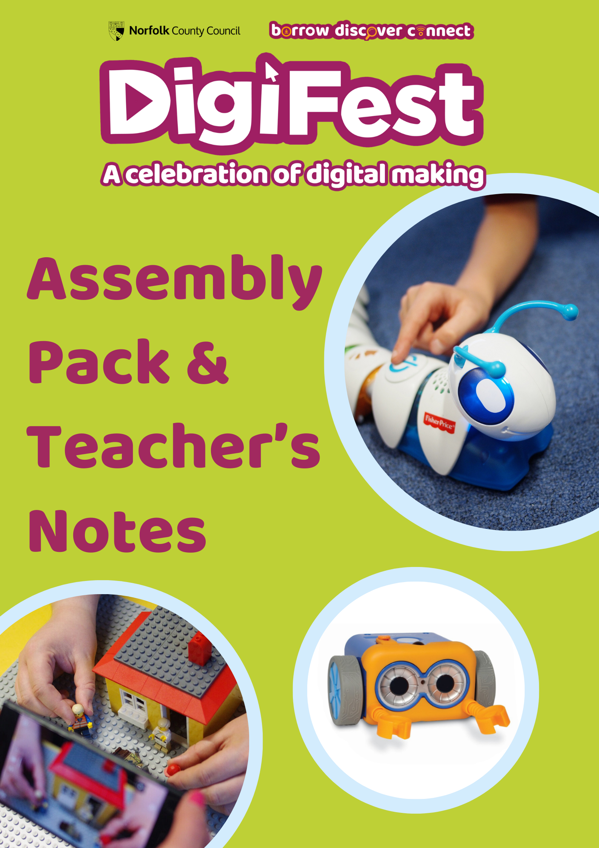

Contents:

* Introduction: What is Digifest?
* Teacher’s Notes & School Assembly Guide Overview
* Video URL
* Letter for Parent/Carer
* Useful Links & Resources

Introduction: What is Digifest?

**Digifest** is an annual programme of events in Norfolk Libraries that encourages young people and families to develop digital skills and literacy. By delivering fun, interactive activities we aim to lower barriers to access and inspire the next generation of problem-solvers, critical thinkers and engaged digital citizens.

**Digifest** sessions are designed to be exciting and aspirational because we know that along with access to computers, lack of motivation and trust are significant barriers to engaging with the digital world. Our emphasis is on inclusion, learning skills, and giving people the chance to experience new technologies in a safe, accessible, and welcoming environment.

Throughout the whole of February there will be over 100 **free** events taking place across the library service, for children aged four to 14. Some events are one-off specials, such as a Lego Stop-Motion event, and the chance to use the Codeapillar or a Coding Critter to start learning about programming. For 2025, we’ve got lots of snazzy tech and robots to meet, but not everything is about coding- there are great digital art and design opportunities too!

What’s in this Pack?

We would really like to draw attention to our programme of free events and have included both **a PowerPoint presentation** and a **video link** for you to share in your school assemblies, along with teachers notes to support you. We would also appreciate if you could draw parents’ attention to our sessions, by sharing with them the useful links included in this pack and/or by sending onto themour parent/carer letter which explains Digifest and the information which may have been shared with their children in school.

Teacher’s Notes & Assembly Guide Overview

Presented are some notes to assist you in the delivery of your Digifest assembly. These can be followed in full or merely used as prompts. There is a video embedded in Slide 7; this can be accessed via the YouTube link.

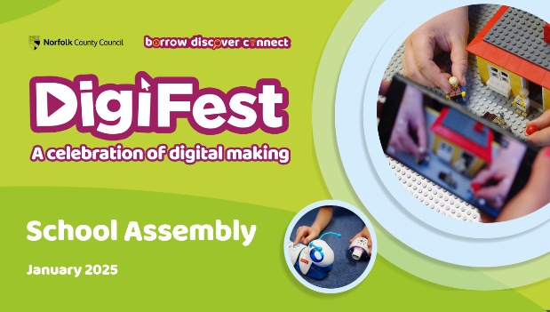

**Slide 1:**

*Starting slide for the assembly*; explain that today you’re introducing a very special series of events happening in Norfolk Libraries.

If you have a library branch nearby, you may want to mention this and ask children if they visit that library.

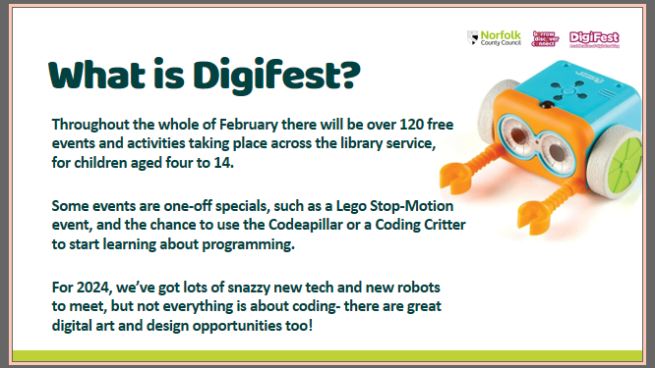

**Slide 3:**

That sounds great, doesn’t it, but where and when is Digifest? Digifest is happening in ALL Norfolk library branches- all 47 of them, so there’s bound to be something you want to attend.

It’s happening for the whole month of February too - from the 1st of Feb onwards.

**Slide 2:**

*Let your pupils know about Digifest by using the text on screen to explain what the programme of events and activities is.*

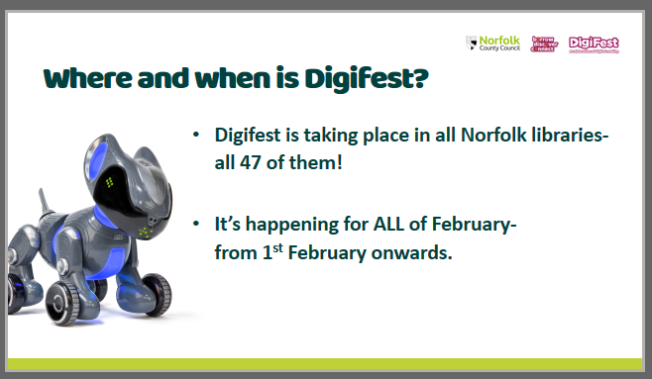

**Slide 4:**

What can you do at Digifest? You can Meet Robots like Codepillar, Pyxel and Artie 3000. Help a Very Hungry Codepillar move around and find food, teach Pyxel the dog to walk and bark and wag its tail, and help code Artie and show him how to create elaborate drawings and works of art right in front of you.

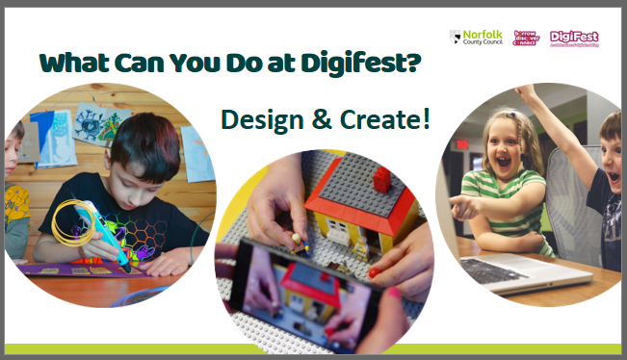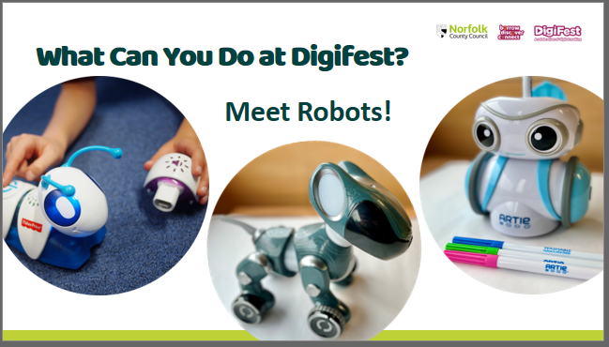

**Slide 5:**

You can also Design and Create at Digifest! Use 3D pens to draw in three dimensions, make your own movie using Lego and stop motion techniques and take part in a code club session to create your own games and animations.

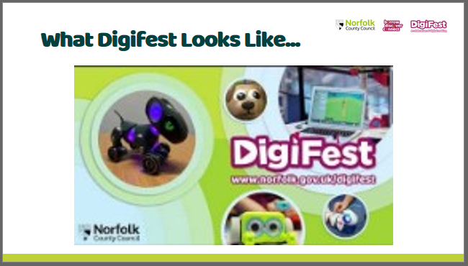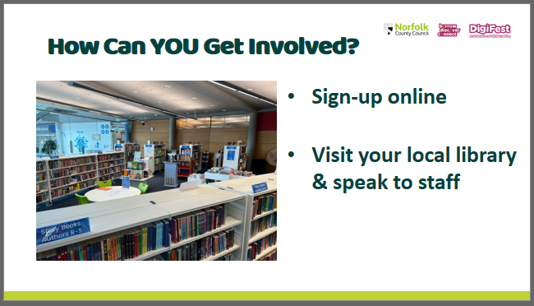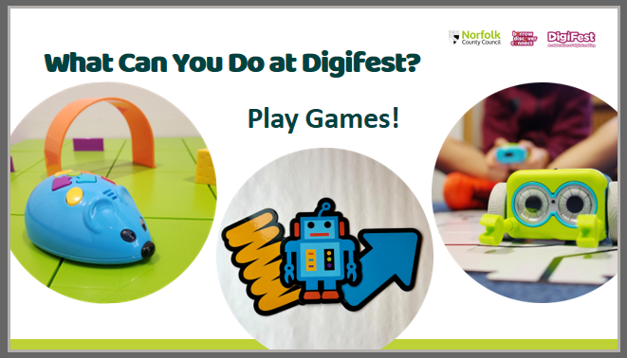

**Slide 8:**

Most important of all - how can you get involved? You can sign up online, and we will share with your grown-ups just where to do this, or you can visit your local library to speak to the brilliant library staff who will be able to help you.

**Slide 7:**

We’ve even been given a video to show you just how fun Digifest can be.

*(Please show video)*

**Slide 6:**

You can even Play Games! Build a maze for Colby the coding mouse to explore, try coding through physical activity and movement and help Botley the Robot to capture aliens and avoid asteroids.

Assembly PowerPoint and Video Link:

If you do not wish to use the PowerPoint to deliver your Digifest Assembly, then you can [find an introductory video here on YouTube](https://youtu.be/21i-7VbNCjw). It can also be [found on the Norfolk County Council Vimeo page](https://vimeo.com/1047154617/2ca75759e0?ts=0&share=copy).

We would suggest you preface the video with the following introduction:

**This February Norfolk Libraries are celebrating digital creativity with children and families! Across the county libraries are hosting free workshops for children and young people aged 0-14. Get hands on with robots, learn coding skills, create animated short films and fabulous 3D designs. There is something to inspire everyone.**

**Look out for old favourites like Code-a-Pillar and Botley, along with sessions like Artie 3000: the robot that can draw, and Let’s Go Code: a physical game that teaches you to think like a robot.**

**Activities will run throughout the month and are suitable for complete beginners and tech enthusiasts alike. You can find out more by visiting your nearest library or by booking online- we will be sharing lots of info with your grown-ups on how to do this.**

Useful Links and Resources:

*Enhance your assembly with these additional resources, which can also be shared with parents/carers on your internal systems like ClassDoJo or Tapestry. We would also appreciate if you could include the Parent/Carer letter to signpost to these links.*

* To explore and book on to events taking place across our libraries throughout Digifest, visit [www.norfolk.gov.uk/digifest](http://www.norfolk.gov.uk/digifest).
* To join the library and explore everything we have to offer, visit [www.norfolk.gov.uk/jointhelibrary](https://www.norfolk.gov.uk/libraries-local-history-and-archives/libraries/join).
* To find your local library: [www.norfolk.gov.uk/libraries-local-history-and-archives/libraries/visit/locations-and-opening-times](http://www.norfolk.gov.uk/libraries-local-history-and-archives/libraries/visit/locations-and-opening-times)

Follow us on social media:

* [Twitter/X: @NorfolkLibs](https://twitter.com/NorfolkLibs)
* [Facebook: @NorfolkLibrariesUK](https://en-gb.facebook.com/NorfolkLibrariesUK/)
* [Instagram: @NorfolkLib](https://www.instagram.com/norfolklibraries/)raries

**This assembly pack was created by Norfolk Library and Information Service; if you would like any further information then please contact:** [**libraries@norfolk.gov.uk**](mailto:libraries@norfolk.gov.uk) **with the subject line “Digifest”**