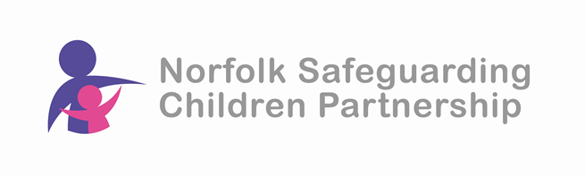
Adultification Training by ListenUp

Delivered via Microsoft Teams

This workshop is aimed at practitioners from across the multi-agency safeguarding network who are working in safeguarding children in Norfolk.

This workshop explores the concept of ‘adultification’ from both a research and practice perspective. This session uses case studies, small group discussions and serious case review findings to explore how adultification manifests in practice and its potentially life-long impact. Participants are introduced to Listen Up’s Professional Inter-Adultification Model which provides a framework for individuals and teams to reflect on practice and guard against the adultification of children and young people.

Session objectives include:
- Understand notions of vulnerability and childhood and how these are applied to some children more than others
- Understand the broad concepts of intersectionality and adultification
- Identify ways to guard against adultification in practice
- Reviewing findings from serious case reviews relating to child criminal exploitation

Dates and times of training:

Tuesday 4th March 2025 – 10am to 2.30pm
Tuesday 18th March 2025 – 10am to 2.30pm

NB if you attended Adultification training with us in March 2024 then this is the same training.

This is a free event but places are limited so to ensure your place please book asap.

To book your place visit the NSCP website training page:
https://norfolklscp.org.uk/people-working-with-children/nscp-training

