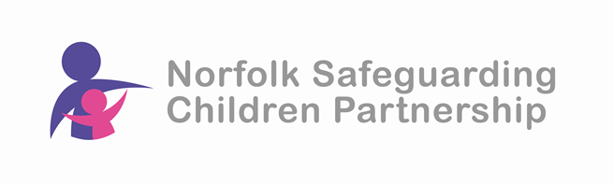
The Impact of Poverty

Who is it for?
All Child and Family Facing Practitioners

Aim:
To achieve a group of practitioners who understand Poverty in the UK and how this impacts upon children and families lived experiences both emotionally, educationally and socially. To increase knowledge and consider ways to identify and support those living in Poverty.

Learning Outcomes:
- Understand the definition of relative and absolute Poverty

- To develop knowledge about the challenges faced by individuals and families living in poverty and most affected by the cost of living crisis/ living in poverty.

- Understand the effects of factors such as poor housing, limited access to resources and financial instability on the parents/carers' ability to provide good enough parenting.

- Understand the effects of poverty on a child's brain development, learning and education

- Have considered the impact on the health and development, including emotional wellbeing, of children and young people

- Have knowledge of local indicators of deprivation and how living in an area of deprivation can impact on a child or young person's likelihood of experiencing abuse or neglect.

- Explore what practitioners can do to support families experiencing poverty

Date
Friday 27th June 2025 – 10.00am to 4.00pm – Microsoft Teams

To book your place visit our website: https://norfolklscp.org.uk/people-working-with-children/nscp-training

Education places can be booked via S4S.

